Lab#02
Implementation of Scanner class for
reading and taking inputs in java.
Objective
To get familiarity with the Scanner Class for reading and taking inputs in java.
Lab Goals
To demonstrate and gain familiarity with the Scanner class in Java for reading and taking inputs:
a. Understand Scanner Class Basics: Gain a foundational understanding of the Scanner
class in Java, including its purpose, syntax, and basic usage for reading input from
various sources such as the console, files, or strings.
b. Practice Input Reading: Learn how to use the Scanner class to read different types of
input data, including integers, floating-point numbers, strings, and characters, and
understand the methods provided by the Scanner class for retrieving this input.
PRINT FUNCTION IN JAVA
java System.out.println() is used to print an argument that is passed to it. The statement
can bebroken into 3 parts which can be understood separately as:
1. System: It is a final class defined in the java.lang package.
2. out: This is an instance of PrintStream type, which is a public and static member field
Of the System class.
3. println(): As all instances of PrintStream class have a public method println(), hence
we can invoke the same on out as well. This is an upgraded version of print(). It prints
any argument passed to it and adds a new line to the output. We can assume that
System.out represents the Standard Output Stream.
Syntax:
- System.out.println(parameter)
Example
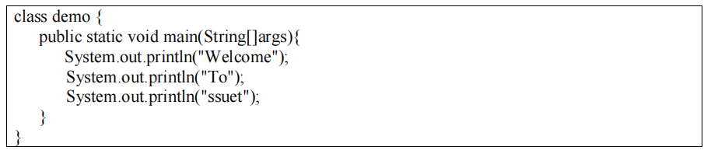

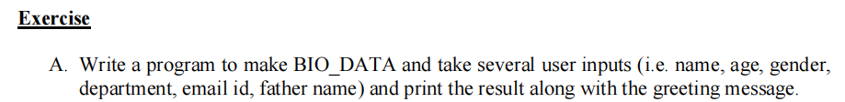
Program:
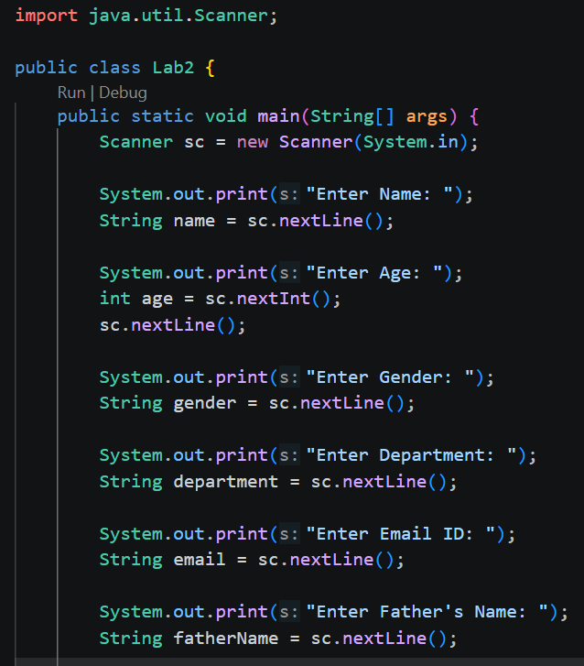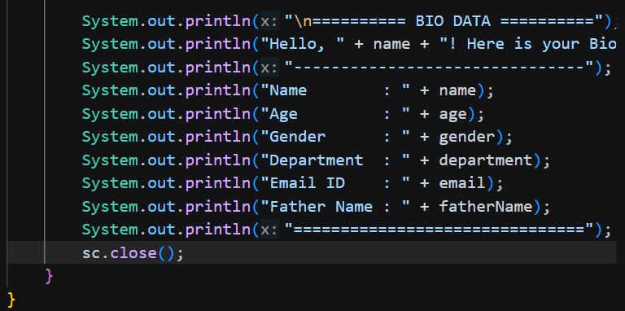
Output:
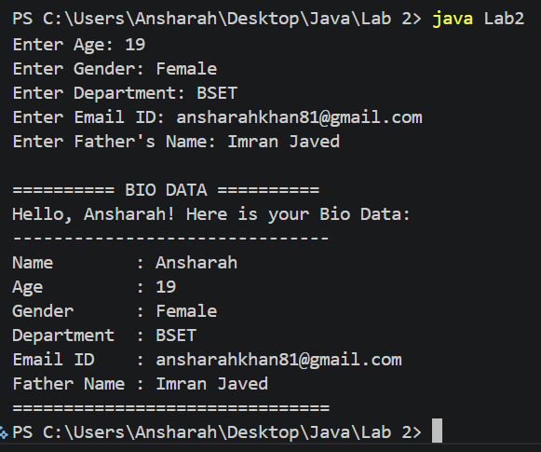

Program:
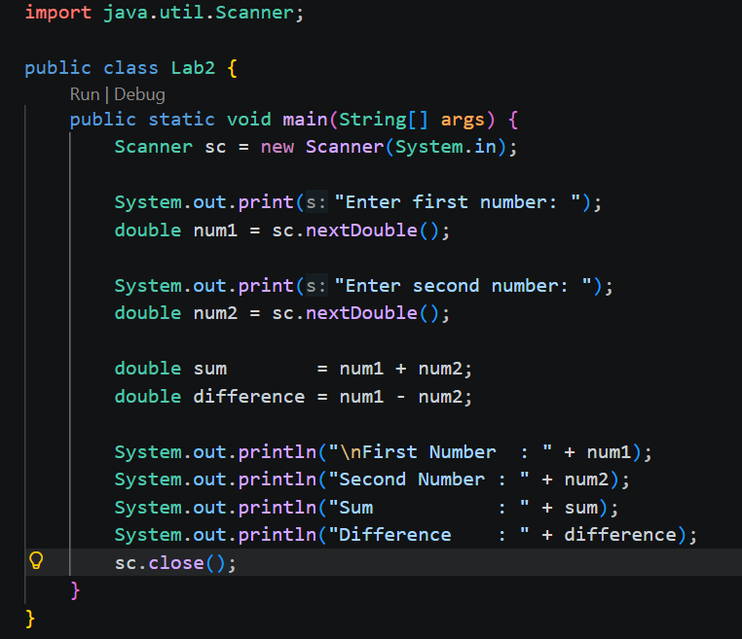
Output:
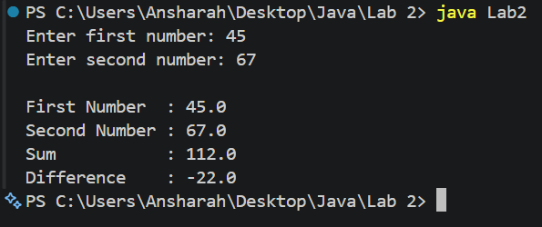
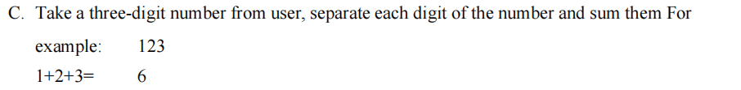
Program:
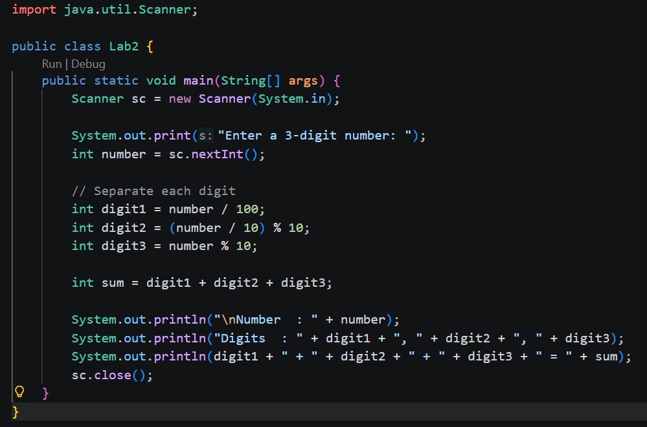
Output:
